Scout Knives “HAND AXE”
Use all information in this document at your own risk
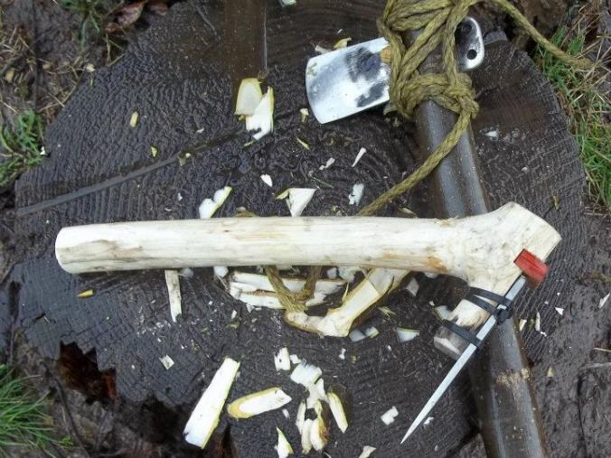
The hand axe was originally a bifacial (meaning shaped on both sides) stone tool and is the longest-used tool of human history used for cutting and chopping chores. The Scout Knives hand axe is made from spring steel and has been coated to help protect it from rusting. There are four main ways to use this tool, they are: hand axe; chisel; axe; and adzes.
The Bundle Handle
This is the fastest easiest handle to build, the only downside is that it takes more para-cord to wrap up the handle. The one pictured is made up of seven sticks of 1/2" or smaller, they we easy to chop up quickly. I use a 25' piece of para-cord to wrap it up, could have been done with a 15' piece but didn't want to cut the cord. For me this a transitional handle on the way to a advanced handle.
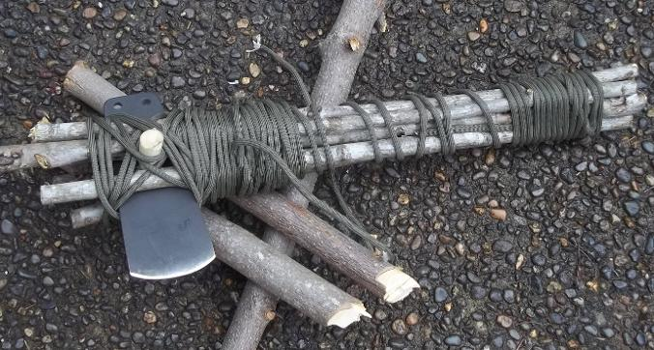
Advance Handle Plans
This handle takes more time to put together then other ones, but is well worth the effort. Because of the added time you might want to start with a simple handle first and then upgrade to this one in a survival situation.
1. Start with a 1.5" diameter green branch for a handle, this can even be the first handle you have. Use the Axe head to split the branch.
2. Put a "V" shaped notch where the front pin goes. If you look you can barely see it in the picture below.
3. Take a 1" green branch and split it into fours, it needs to be about three to four inches long.
4. With the blade in place set one of the four pieces on each side of the handle and mark for the cuts.
5. Cut the notches into the handle like the picture below.
6. Install the sticks and wrap it up. 550 cord works better than anything else for warping the handle, but small rope or zip ties works.
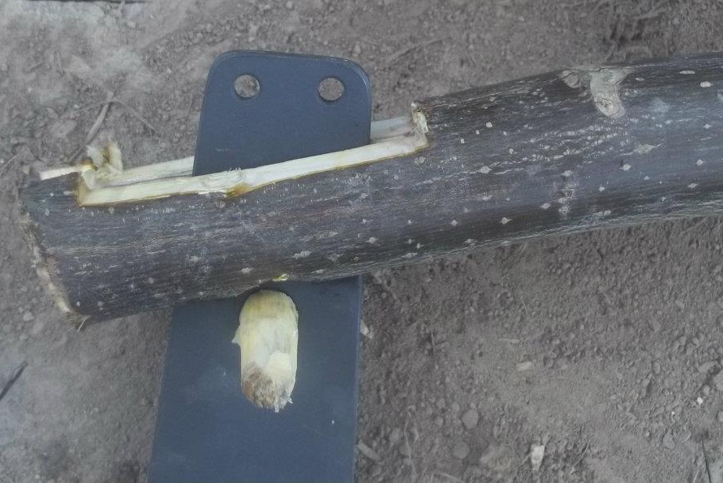
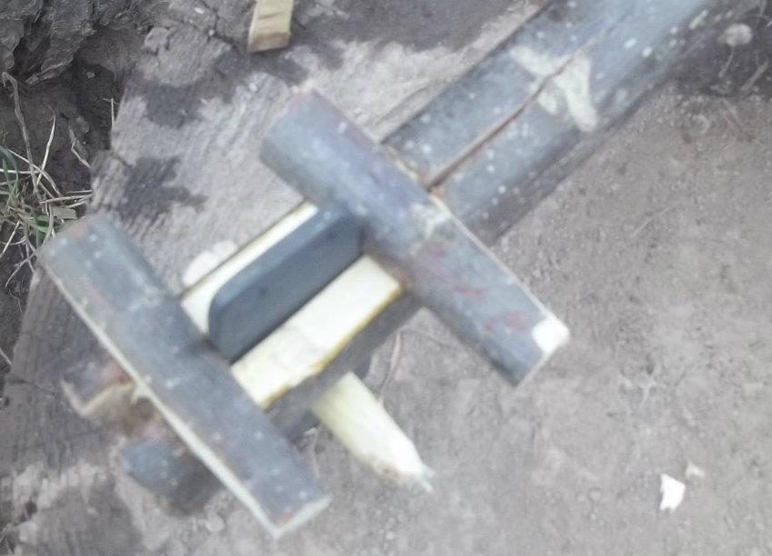
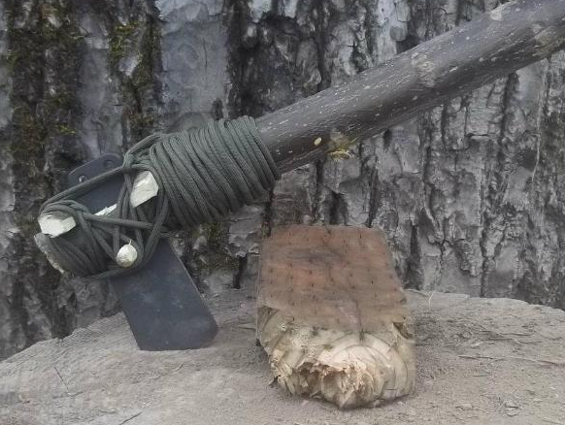

www.scout-knives.synthasite.com

Outdoor tips and tricks
Use all information in this document at your own risk
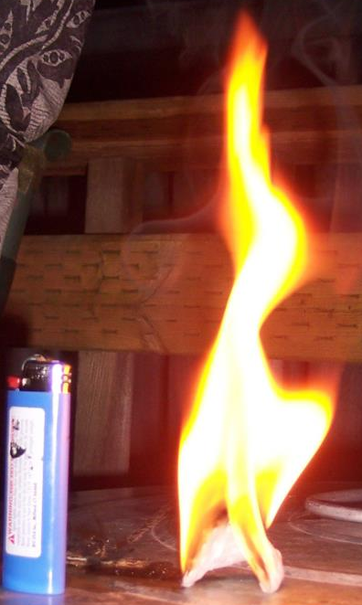
Homemade fire starter in action, 5 to 7 minute burn time. To make the fire starters take 100% cotton face pads and dip them in a melted mix of 75% petroleum jelly and 25% wax. Once they are dry store in a zip lock bag.

Figure Four trap
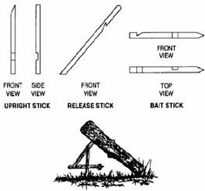

Chemically treat water
For me this is a last resort, the water taste horrible and you have to make sure you chemical is not out of date and you use it right. Avoid using bleaches that contain perfumes, dyes and other additives. Be sure to read the label.
- Place the water (filtered, if necessary) in a clean container.
- Add the amount of bleach according to the table below.
- Mix thoroughly and allow to stand for at least 30 minutes before using (60 minutes if the water is cloudy or very cold).

Treating water with 5-6% Bleach
Volume of water | Clear or Cloudy | Cold or Surface water
1 quart / 1 liter | 3 drops | 5 drops
1/2 gallon | 5 drops | 10 drops
1 gallon | 1/8 teaspoon | 1/4 teaspoon
5 gallons | 1/2 teaspoon | 1 teaspoon
10 gallons | 1 teaspoon | 2 teaspoon

Homemade filters
You can make a good homemade water filer by layering sand, gravel, and charcoal. I would also do two sets of layers to get the best results. Plus I would plan on boiling the water after to make it as safe as possible, given the source of water you might be forced to use in a disaster.
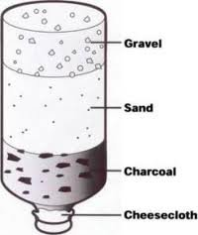
Notes:_____________________________________________________________________________________________________________________
www.scout-knives.synthasite.com

